|  |  |
| --- | --- |
| Power BI Lab Day 3 Document | |
|  |  | | |
| **Writer:** | I&D Microsoft | | **Initials entity:** |
| **Date creation:** 26/04/2018 | |  | **Last upgrade:** 30/04/2018 |

Power BI LAB DOCUMENT

DAY 3- Lab 1

|  |  |  |  |  |
| --- | --- | --- | --- | --- |
| Version | Author | Comment | Reviewed By | Date |
| V 1.0 | I&D Microsoft | Initial draft | Moupiya Das |  |
|  |  |  |  |  |
|  |  |  |  |  |

**Pre-requisites**

Installed and working Power BI Desktop setup.

**Environment Setup**

To install Power BI Desktop to your machine or to sign up for Power BI Service, Refer to Power BI Lab Exercise Day 1.

**Lab Overview**

This lab comprises of four tasks:

1. In the first task, you import the data from an excel sheet.

2. In the second task, you will edit queries using query editor.

3. In the third task, you will perform transformations and create visuals to represent the data.

4. Fourth, you will optimize you data accordingly.

**Case Scenario**

The AdventureWorks Database is a sample database file which supports a fictitious, multinational manufacturing company called Adventure Works Cycles. The AdventureWorksdatabase excel sheet has 27 different sheets in total.

We will be importing 4 sheets to perform the various tasks in the Lab. We need to create an optimized data model using Power BI Desktop in order to achieve the desired results. To accomplish this, we would be focusing on the relationship View, measures, calculated tables and columns and various other options that would help us get a better insight of the data.

# Table of Contents

Table of Contents 3

1. Import Data 4
2. Edit Query …………………………………………………………………………………………………………………………..…………….…….7
3. Transform & Visualize Data…………………………….…………………………………………….…………………………..…………..10
4. Data Optimization…………………………………………………………………………………………………………………………..……..19

# 1. Import Data

1. Start with a blank Power BI Desktop file.
2. Click on Get Data option in the ‘Home’ tab and choose Excel.

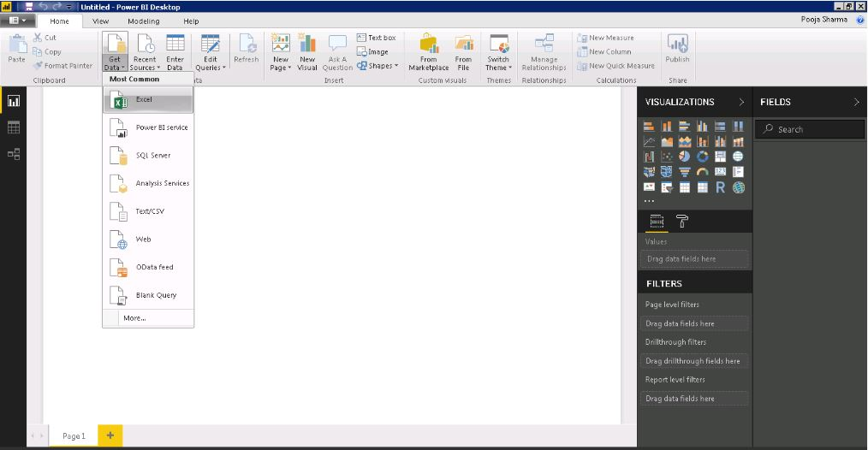

1. Select AdventureWorksDatabase, from the browse menu and click Open.

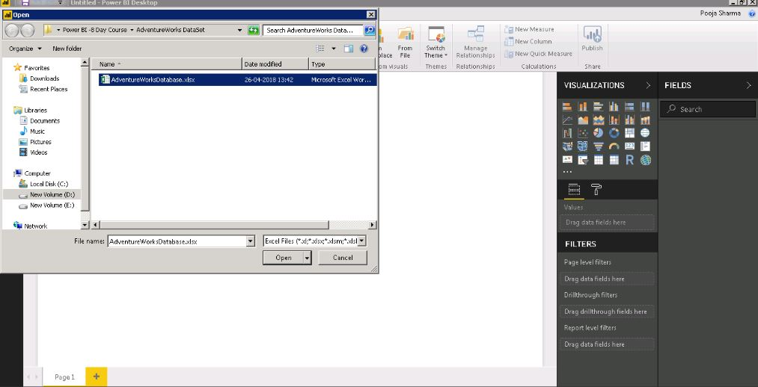

It would take a little time to connect to your database.

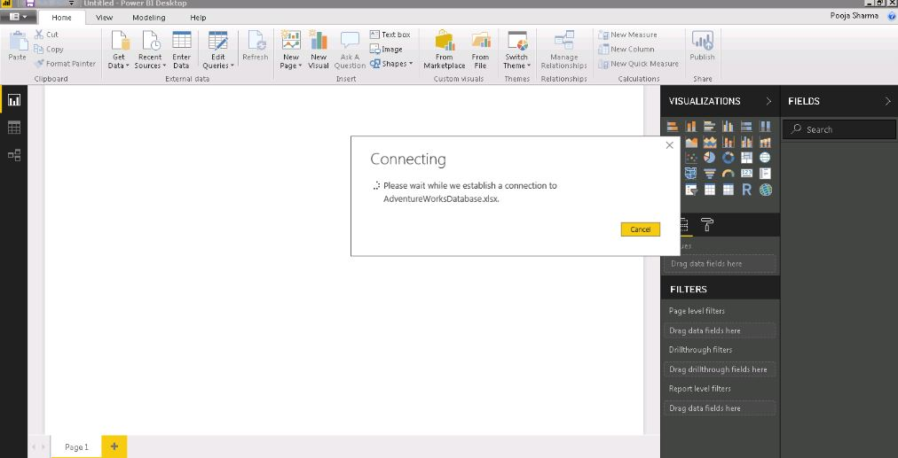

1. From the Navigator menu, select the four table i.e DimProduct, DimProductCategory, DimProductSubCategory and FactInternetSales and click ‘Load’.

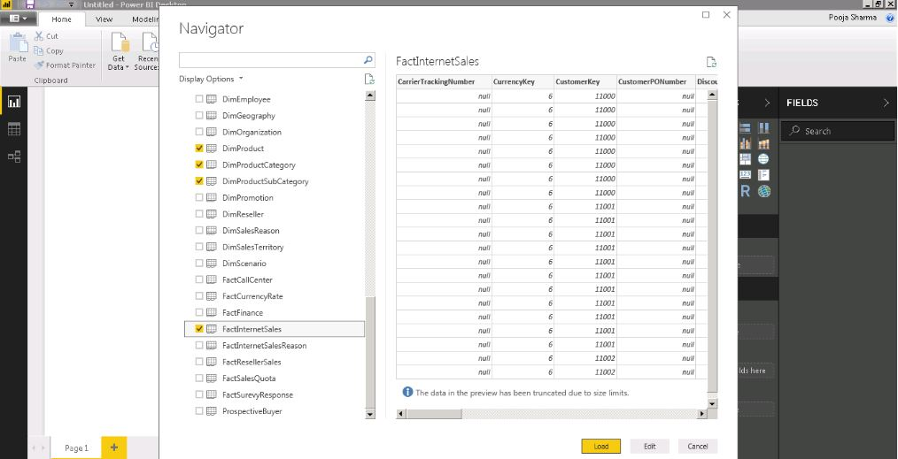

The data may take some time load, connect and evaluate relationships between the sheets loaded.

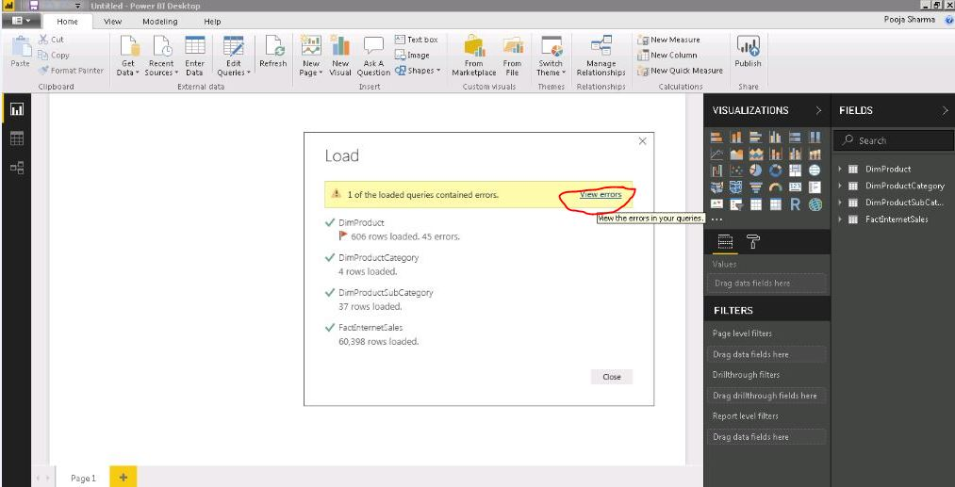

1. In case you find errors loading the data, click on View Errors. This would open the Query Editor for the Power BI file.

# 2. Edit Query

1. In our Scenario, the error is in the ‘Size’ column of the DimProduct table.

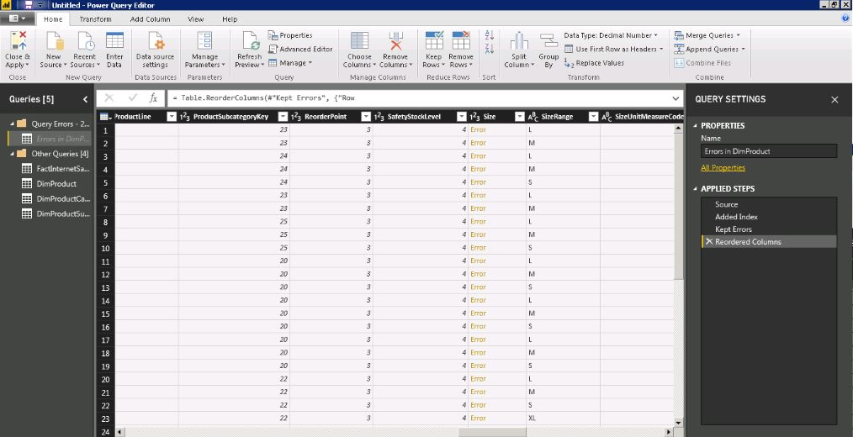

1. To handle this Error, Go to Other Queries Group and select DimProduct table. In the Advance Editor option, change the data type of column ‘Size’ from ‘Int64.Type’to ‘type text’.

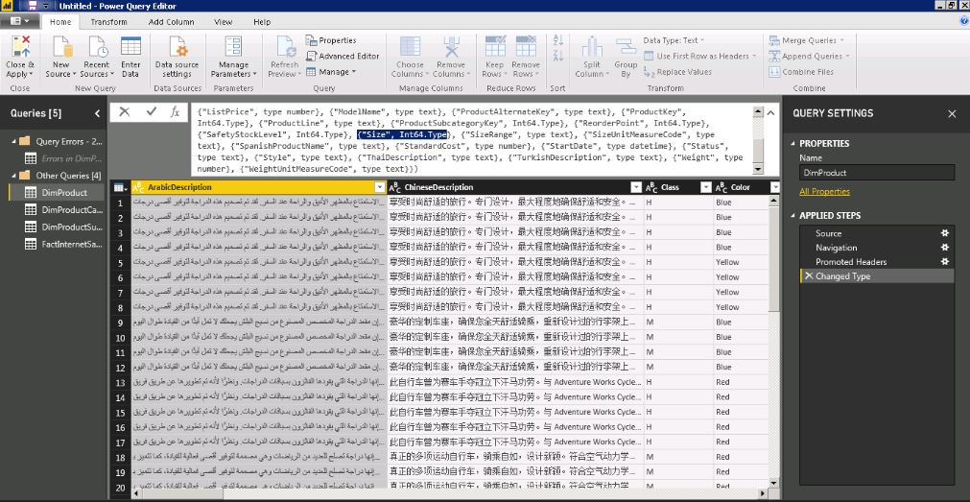

1. If there are no errors remaining, delete the errors sheets from Query Error Group.

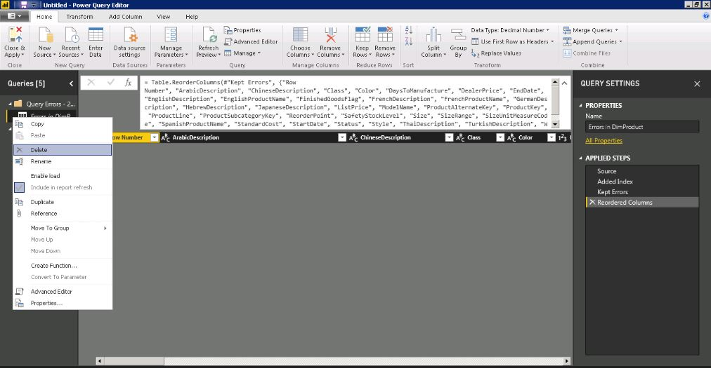

1. Delete the Query Error Group.

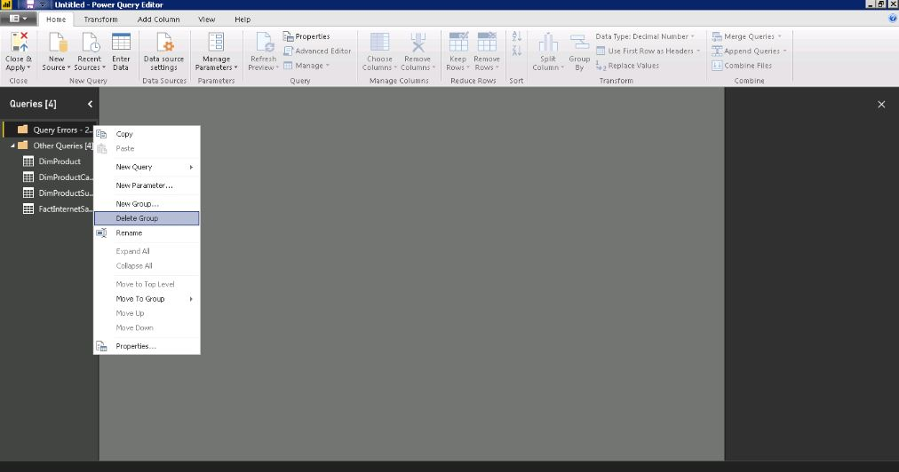

1. Click ‘Close & Apply’ to save your changes made.

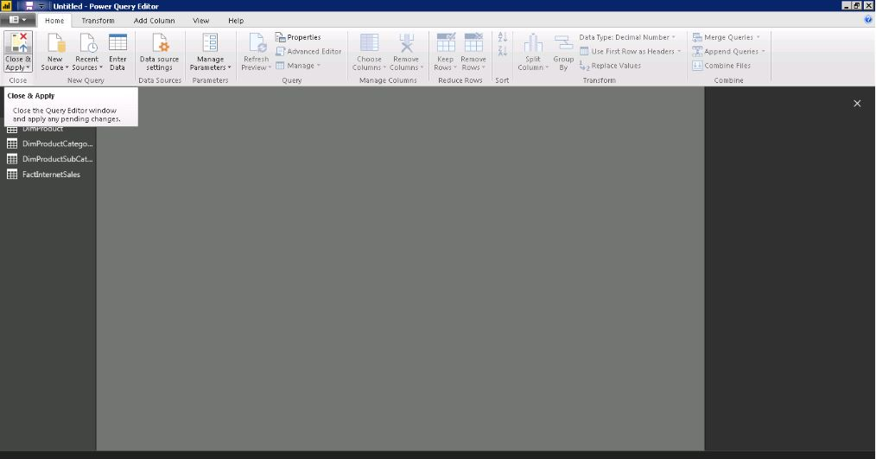

This would close your Query Editor tab.

# 3. Transform & Visualize Data

1. From the Relationships View, select Manage Relationships.

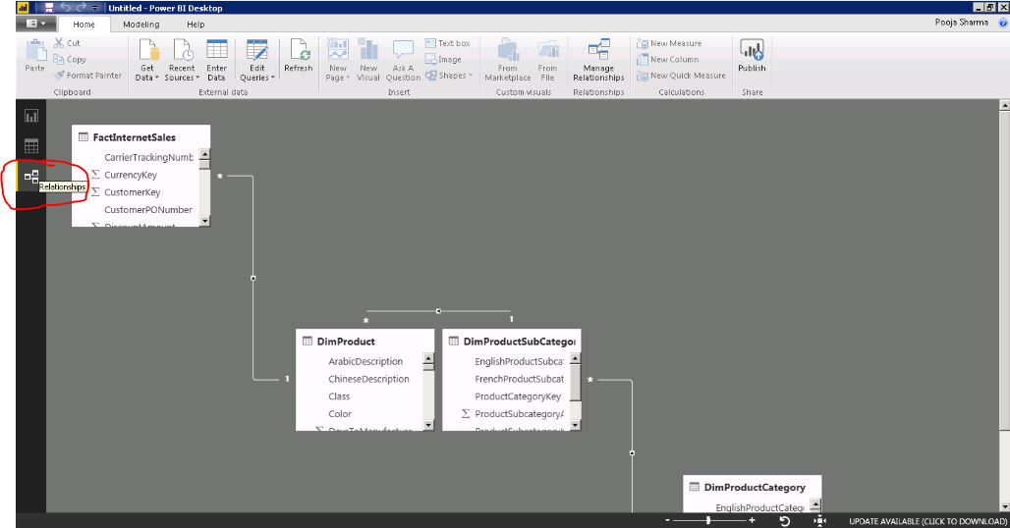

1. In the Manage Relationships menu, you can see options to add/delete relations, autodetect and Edit. Click on Edit option.

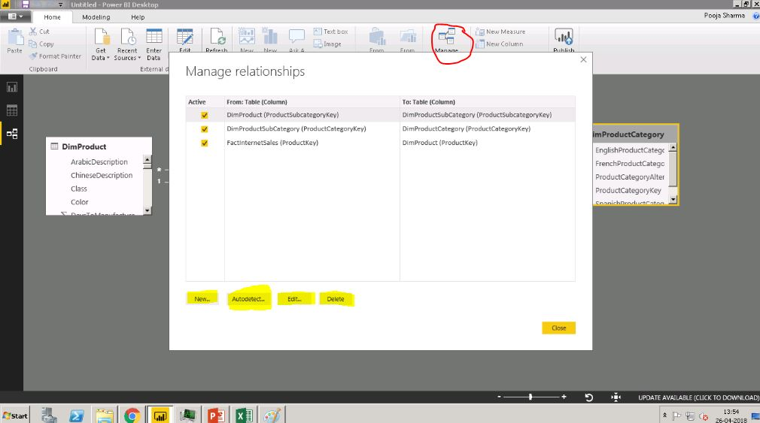

1. In the Edit Relationship dialogue, change the cross filtering direction from Single to Both for the relationship between DimProduct and DimProductSubCategory.

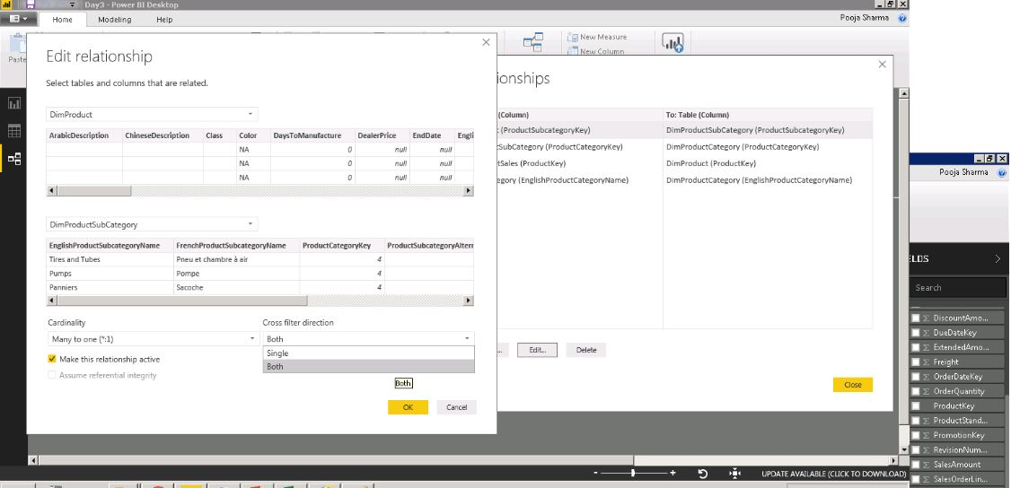

1. Similarly, do this for the remaining two relationships using Edit.

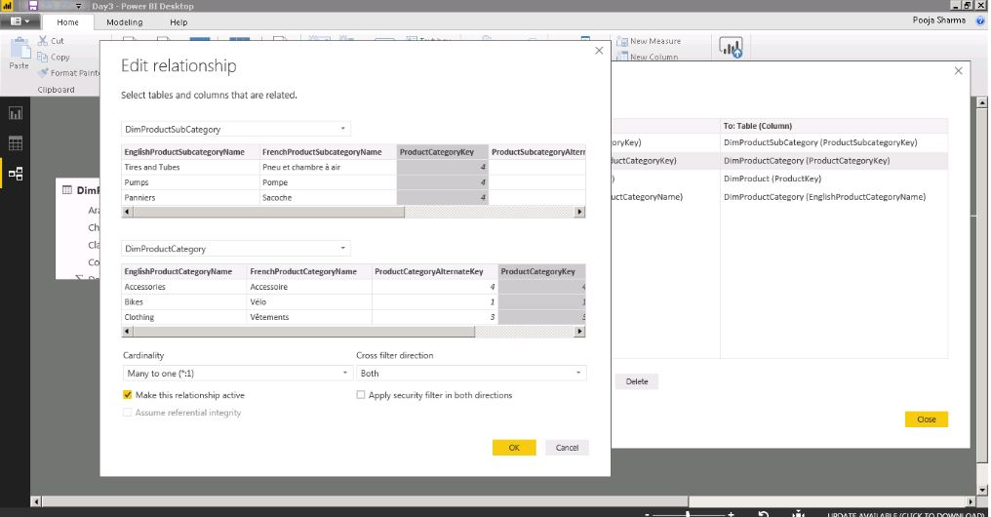

You can also edit the relationship between two table by double clicking on the link that connects the two table as shown in the screenshot.

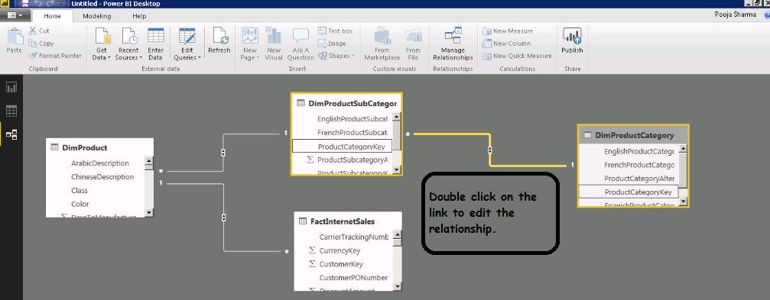

1. In the Data view Pane, first select the table FactInternetSales. From the fields pane. Now, click ‘New Column’ to create a calculated column in table FactInternetSales.

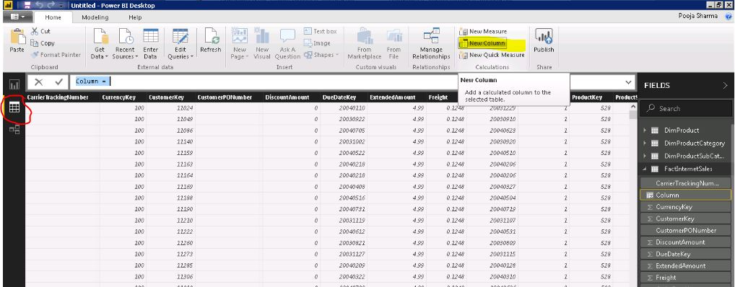

1. Use formula: TotalPrice = FactInternetSales[OrderQuantity]*FactInternetSales[UnitPrice] and hit Enter.

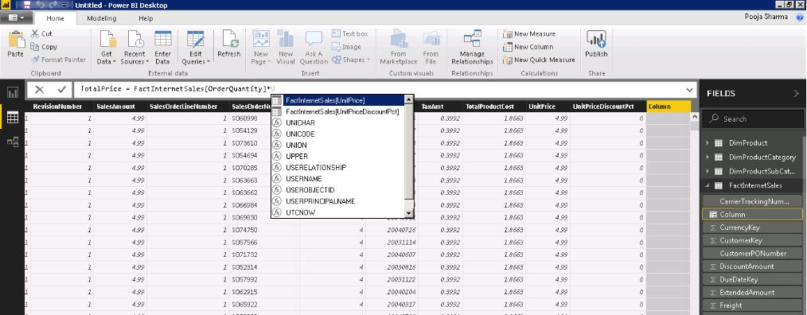

1. From the visualizations pane, in the Report View choose stacked column chart.

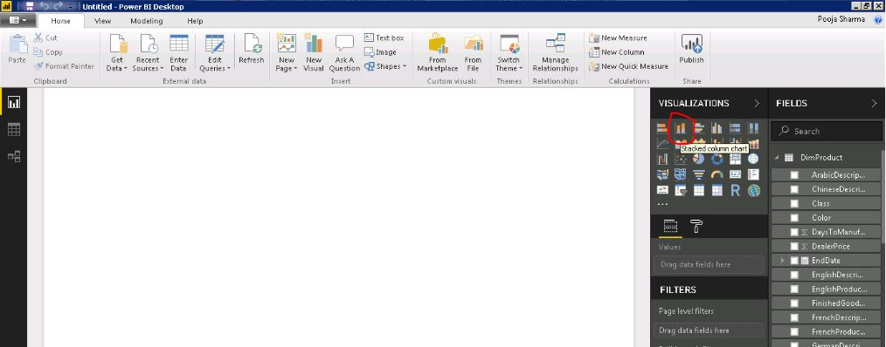

1. Select the calculated column ‘Total Price’ from table FactInternetSales to put on Values field and EnglishProductSubCategory from table DimProductSubCategory.

You may drag and drop the fields from table to their respective groups. Eg. Values – Total Price, Axis- EnglishProductSubCategory.

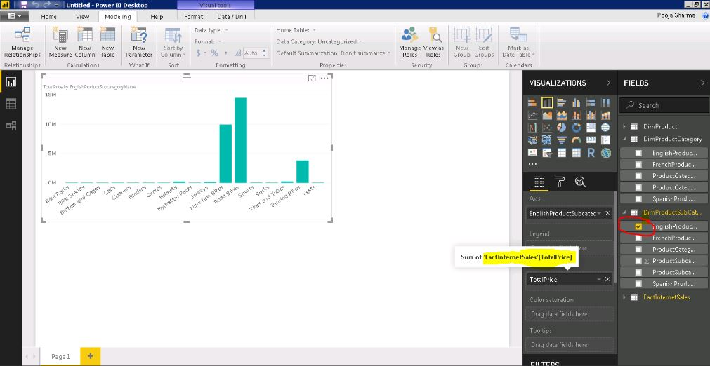

You may resize and format the font type and size of the data in the visual using Format pane.

1. Now, we create a measure by clicking ‘New Measure’ tab in the Home Pane.

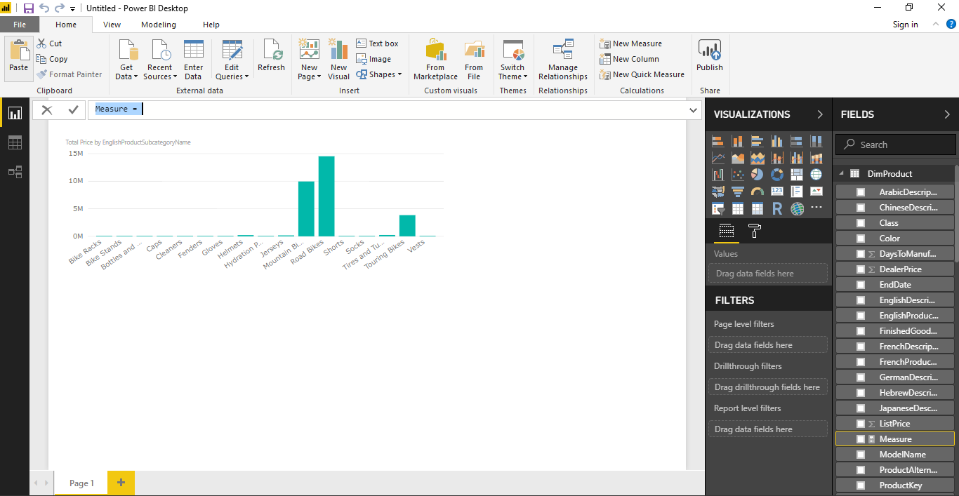

1. Use the Formula Total sum of Total Price = Sum(FactInternetSales[Total Price]) to calculate measure and hit enter.

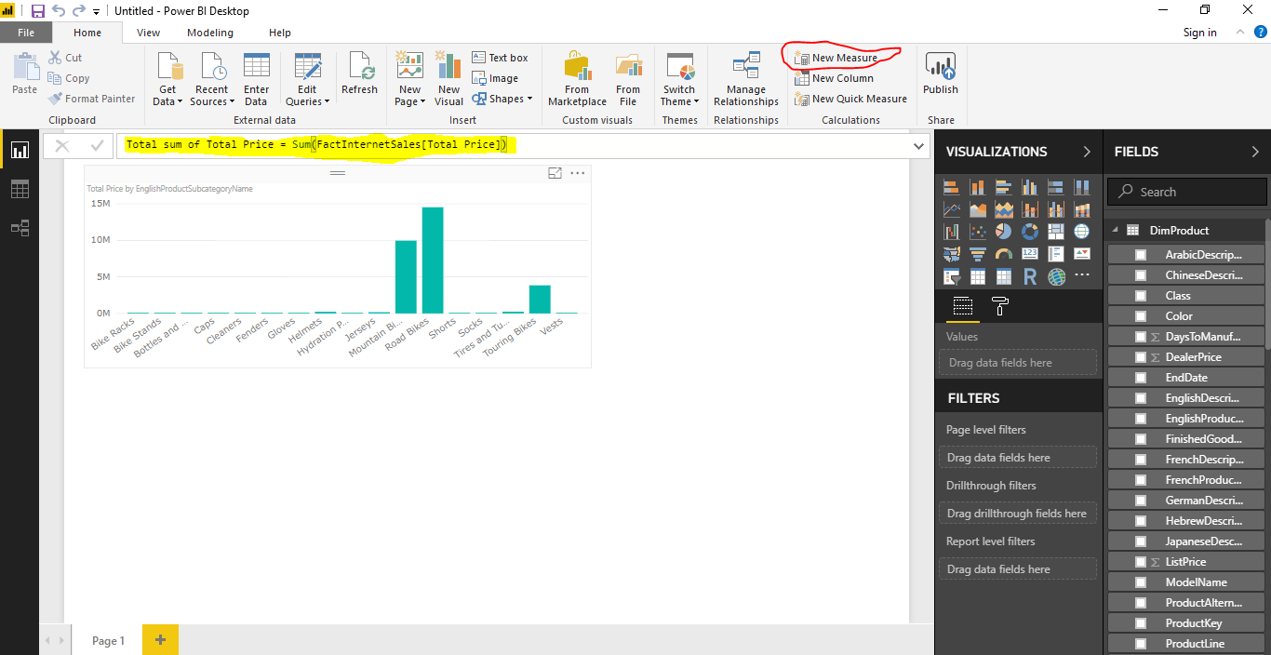

Note:  A **measure** is evaluated **in the** context of the cell evaluated **in a** report or **in a** DAX query, whereas a **calculated column** is **computed** at the row level within the table it belongs to.

1. To change the location of the measure created, select the measure and go to modelling tab.

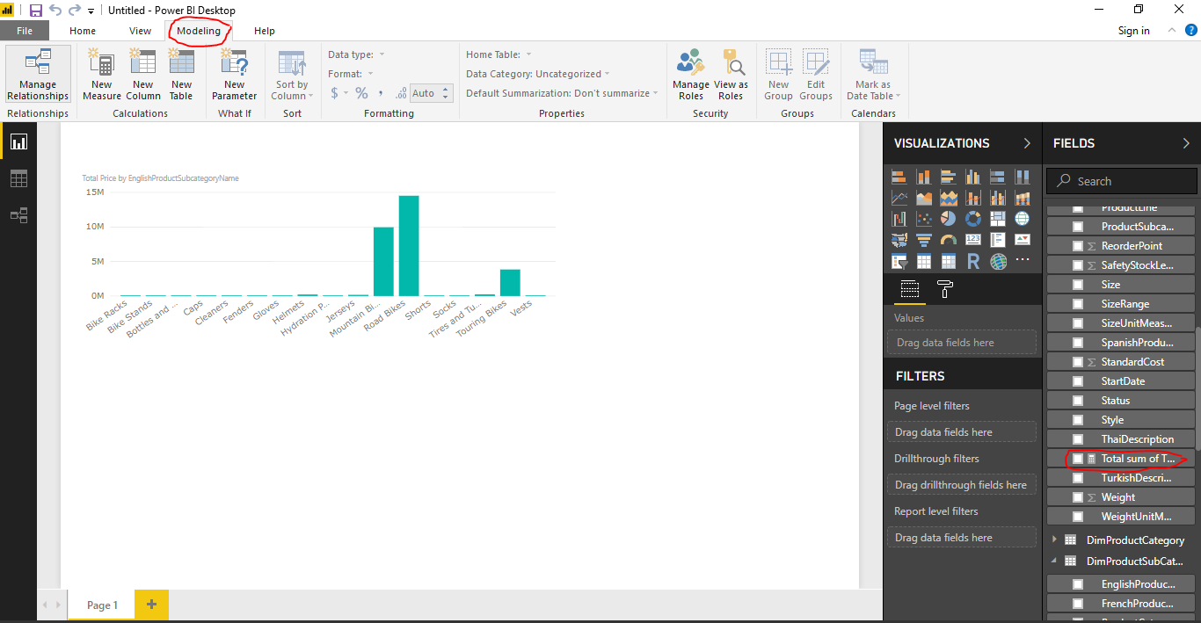

1. Choose from the home table, select table you want to put the measure into.

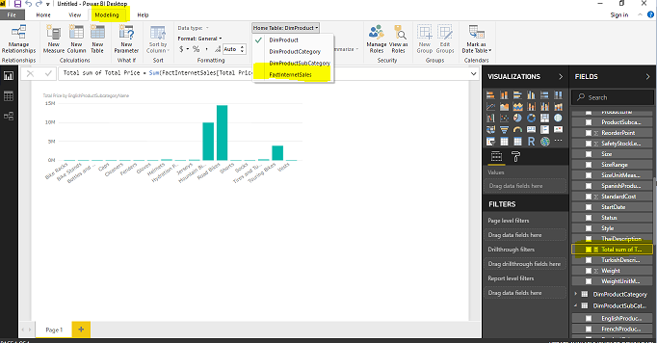

1. Use a card visual to put the measure Total Sum of Total Price in the value field.

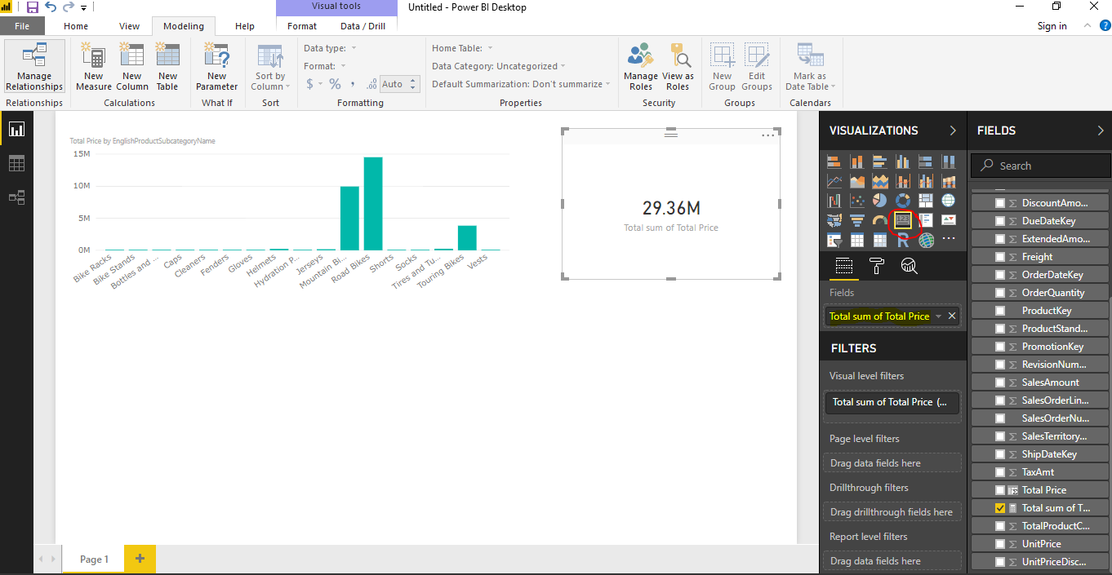

1. From the modelling tab, now we create a calculated table for distinct EnglishProductCategoryName.

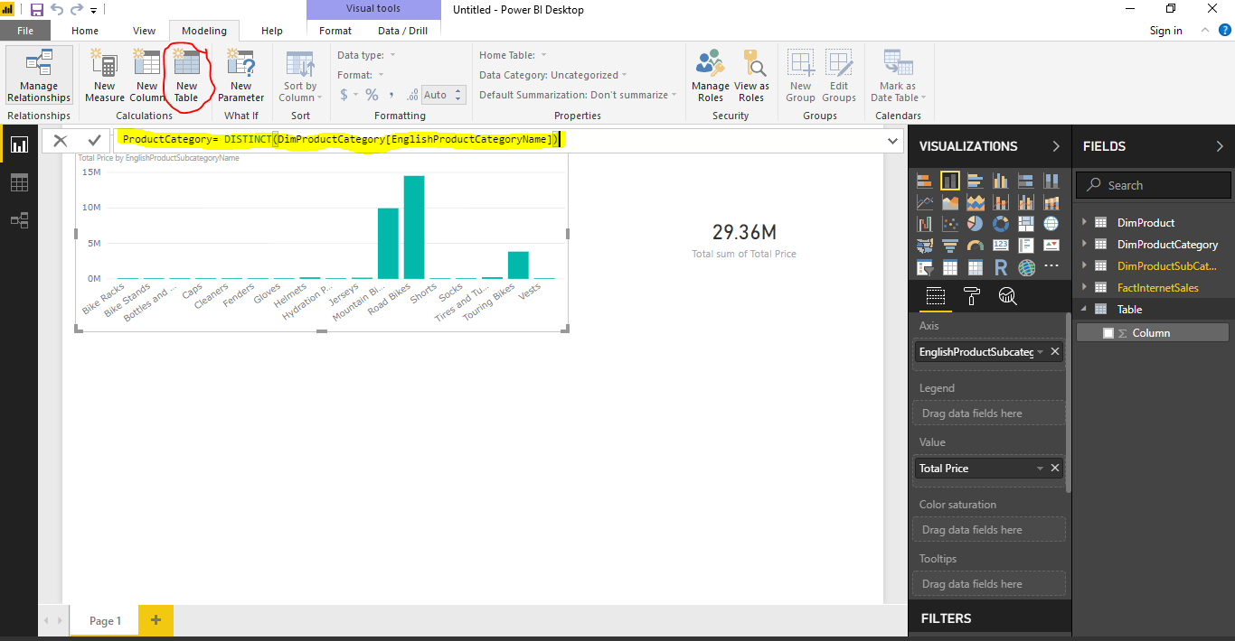

Use formula ProductCategory= DISTINCT(DimProductCategory[EnglishProductCategoryName]) and hit enter.

1. In Relationship View, create a relationship between the new table ProductCategory and DimProductCategory using Manage Relations.

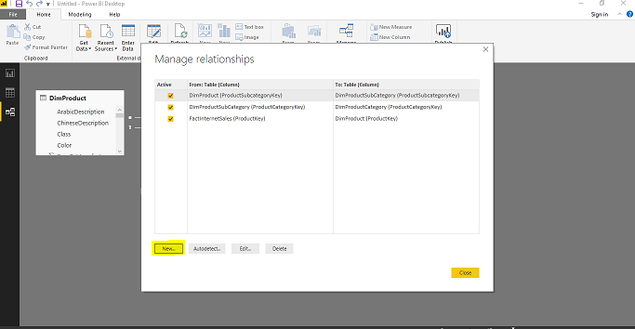

1. Click on New to manually add the relationship.

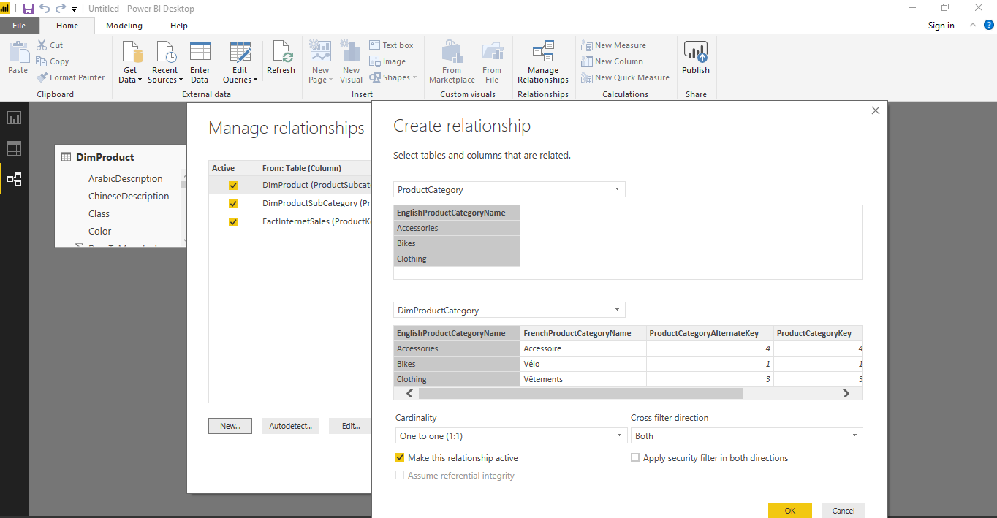

Click OK, then close.

1. In the Report View, from the visualization pane, select the pie chart visual and use the field EnglishProductCategoryName from table DimProductCategory as Legend and measure Total sum of Total Price as Values.

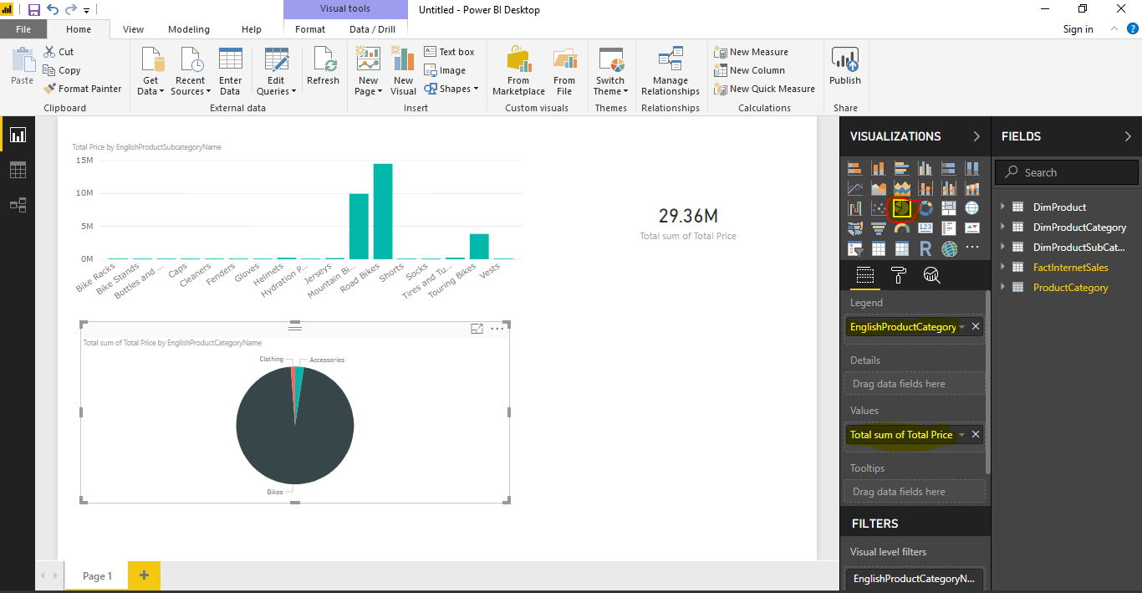

# Data Optimization

1. In the Fields Pane, select any column you wish to sort according to a column. In our case, we select EnglishProductName from table DimProductSubCategory. Go to Modelling Pane.

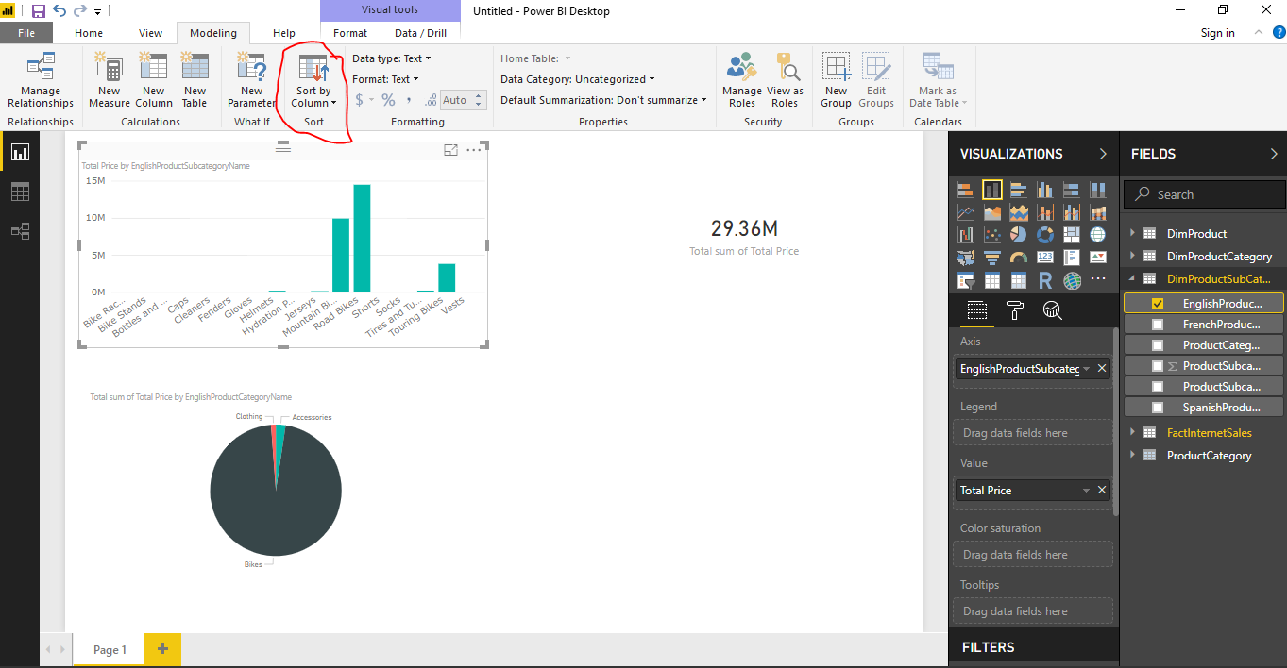

1. Click on ‘Sort by Column ’ and from the options given, choose the column ProductCategoryKey.

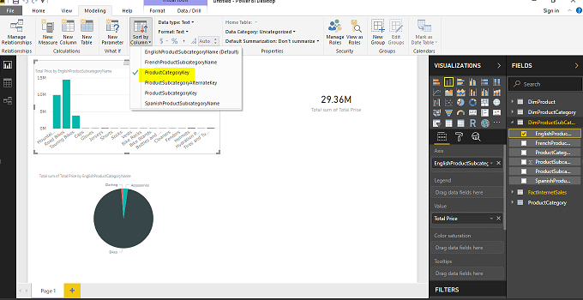

1. To Hide unwanted columns, go to fields pane, right click on table name or column name and click ‘Hide’.

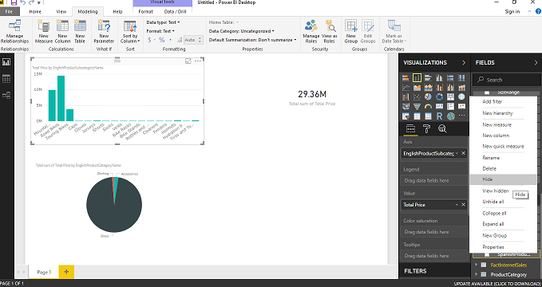

1. Another way of hiding the table is through relationships view. Go to Relationship View and right click on the table you wish to hide.

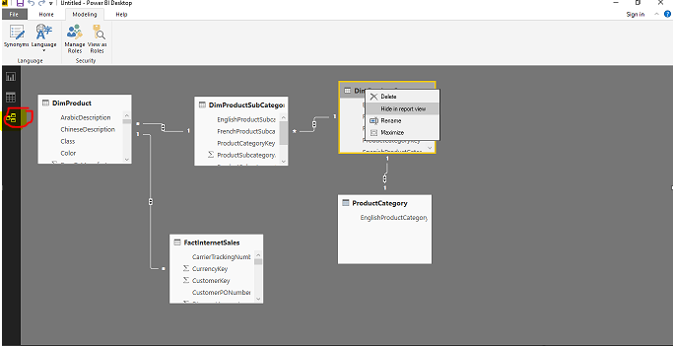

1. You can also change the data type of any column in the tables. Just Select the column, go to modelling tab and change data type like shown below.

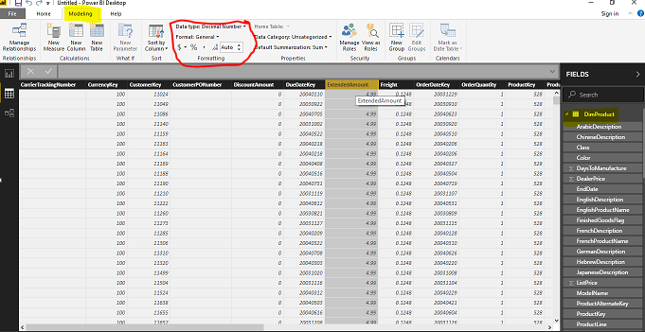

1. You can also change the data Category of the column from a list of options. In our case, we let it as it is.

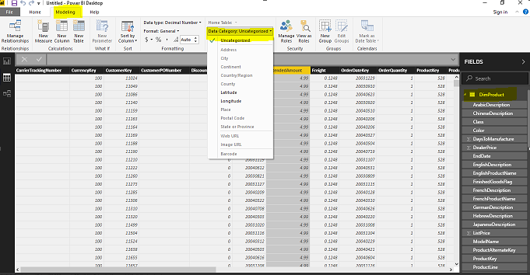

1. Click ‘save as’ from the File menu to save your Power BI Report.

**Summary**

In this Lab exercise, we have learnt:   
  
1. to import data from an Excel File.

2. To remove errors in the Query Editor.

3. To create, delete and edit Relationships between tables through Relationship view.

4. Data View and to create calculated columns, calculated table and measures.

5. Use of Visuals like stacked column chart and Pie chart.

6. To optimize the data according to our needs. I.e. hiding tables/columns, sorting columns and changing data types.